
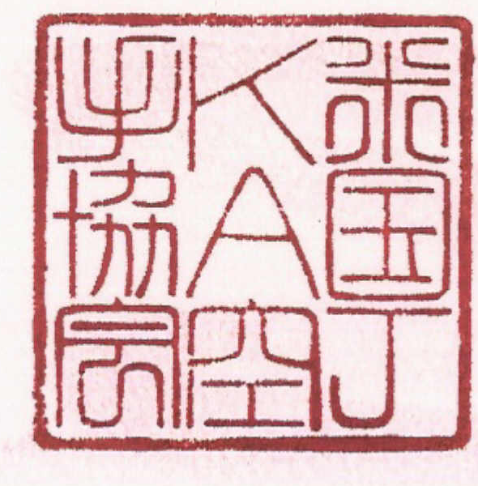

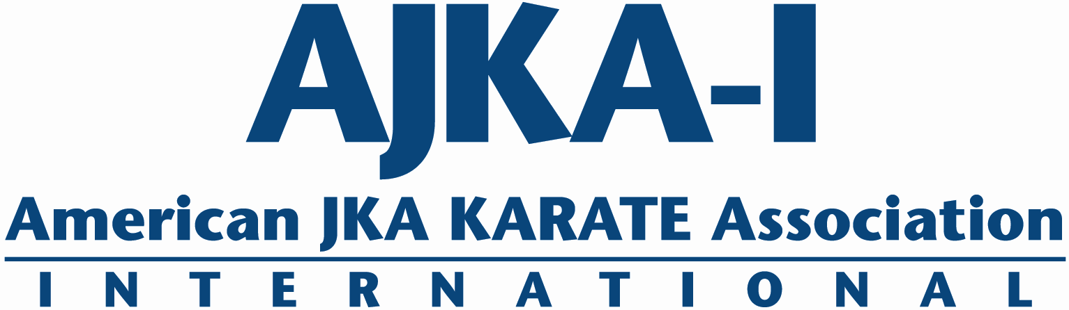
Fee Schedule:
AJKA Karate Association International
@ The Solebury Club
Traditional Shotokan Karate
Two Days of Pure World Class Shotokan!
Shotokan Symposium
Feb 16 – 17, 2019
$180 for two days of training or
$45 a session, $90 a day

Register now! Space is limited!
Venue: The Solebury Club
4612 Hughesian Dr. Buckingham, PA 18912
www.thesoleburyclub.com

Dear Friends of Shotokan –
Join us February 16-17, 2019 for 2 days of the Best Shotokan Karate Training - Anywhere!
Leading this year Symposium will be the following AJKA-I Instructors:
- Sal Lopresti 8th dan – AJKA-I International Technical Committee. NJ
- Avi Azoulay, 7th dan – AJKA-I International Technical Committee. NY
- Rob DeAngelis, 7th dan – AJKA-I International Technical Committee. PA
- Kevin Warner, 7th dan – AJKA-I International Technical Committee. CA
- David Gomez, 5th dan – AJKA-I International Technical Committee, GA
- Ed Rumick, 5th dan - AJKA-I International PA Technical Committee, PA
- Amy Hung, 5th dan - AJKA-I International CA Technical Committee, CA

As a group we are dedicated to providing an intense, challenging, and enjoyable weekend of world-class training and study.
Please read below for symposium logistics and information. Also feel free to contact me directly at 215-519-9310 or deangelis@ajkai-usa.com for further information.

Yours in Budo,
Rob DeAngelis

Sunday 2/17/19
9:00am – 10:15am (Session 4)
Dojo Adult All Levels

10:30am – 12:00pm (Session 5)
Dojo 1st Dan and Above
Studio 1 1st Kyu and Below

1:00pm – 2:20pm (Session 6)
Dojo 1st Dan and Above
Studio 1 1st Kyu and Below

2:30pm- 3:00pm (Camp Closing)
Dojo All Ranks
Saturday 2/16/19
7:30-8:45am (Session 1)
Dojo Adult All Levels
9:00-10:00am
Youth Training General (Session A)
10:15am – 11:45am (Session 2)
Dojo 1st Dan and Above
Studio 1 1st Kyu and Below
12:00-1:00pm
Youth Training Kata (Session B)
1:00pm – 2:45pm (Session 3)
Dojo 1st Dan and Above
Studio 1 1st Kyu and Below
3:00-4:00pm
Youth Training Kumite (Session C)
Shotokan Symposium 2019
Training Schedule
***Note no early registration discounts for individual sessions or Youth Sessions
Whole Camp: $180
One day: $90
Any 1 Session: $45
Youth Single Session: $30
Youth All 3 Sessions: $75

ALL CHECKS PAYABLE TO: AJKAI-USA
OR PAY ONLINE: http://www.ajkai-usa.com/
Name:___________________________________________ Age:____ Gender:____ Address_____________________________________________________________ Home/cell #_____________________ Email Address _________________________ Sensei/Dojo________________________________ Your Rank _________________
Class Registration -Check the Session you are registering:
Adults: Session 1 [ ] Session 2 [ ] Session 3 [ ] Session 4 [ ] Session 5 [ ] Session 6 [ ]
Adult total number of sessions [ ] x $45 = $__________
Full Day $90 [ ] (Saturday/Sunday) Full Camp $180 [ ]
Youth: Session A [ ] Session B [ ] Session C [ ]
Youth total number of session [ ] x $30 = $___________ Full Day $75 [ ]
= Registration Total $_________
I, the undersigned do herby volunteer my application for the attendance and participation in the 2017 Shotokan Symposium, and do hereby assume full responsibility for all injuries, damages, or losses that I may sustain or incur, if any, while attending/participating. I do hereby waive all claims against AJKAI-USA, Solebury Club LLC, individually or otherwise, for any claims or injuries I may sustain. I fully understand that any medical treatment given to me will be first aid type only. I certify that I am in good health and without injuries or physical disabilities. I consent that any pictures furnished by me or taken of me in connection with the seminar can be used for publicity, promotion, or television showing and waive compensation in regard thereto. I further agree to conduct myself with decorum in the spirit of Karate-‐Do.
Signature................................................................................ Date.....................
Parent/Guardian (under 18).............................................................................
Please submit applications and fees to us for early processing. Must be received by February 10, 2019
Website: www.ajkai-usa.com Email: azoulay@ajkai-usa.com
The Solebury Club, 4612 Hughesian Drive, Buckingham, PA 18912 Phone: 215-794-3494

